# docker docker-compose离线安装部署

## 一 docker离线安装

### 1 下载地址

<https://download.docker.com/linux/static/stable/x86_64/>

### 2 解压

tar -zxvf docker-20.10.20.tgz

### 3 将解压出来的docker文件复制到 /usr/bin/ 目录下

cp docker/* /usr/bin/

### 4 docker.service文件

cat > /etc/systemd/system/docker.service << EOF  
[Unit]  
Description=Docker Application Container Engine  
Documentation=https://docs.docker.com  
After=network-online.target firewalld.service  
Wants=network-online.target  
  
[Service]  
Type=notify  
# the default is not to use systemd for cgroups because the delegate issues still  
# exists and systemd currently does not support the cgroup feature set required  
# for containers run by docker  
ExecStart=/usr/bin/dockerd --selinux-enabled=false --insecure-registry=127.0.0.1  
ExecReload=/bin/kill -s HUP $MAINPID  
# Having non-zero Limit*s causes performance problems due to accounting overhead  
# in the kernel. We recommend using cgroups to do container-local accounting.  
LimitNOFILE=infinity  
LimitNPROC=infinity  
LimitCORE=infinity  
# Uncomment TasksMax if your systemd version supports it.  
# Only systemd 226 and above support this version.  
#TasksMax=infinity  
TimeoutStartSec=0  
# set delegate yes so that systemd does not reset the cgroups of docker containers  
Delegate=yes  
# kill only the docker process, not all processes in the cgroup  
KillMode=process  
# restart the docker process if it exits prematurely  
Restart=on-failure  
StartLimitBurst=3  
StartLimitInterval=60s  
  
[Install]  
WantedBy=multi-user.target  
EOF

chmod +x /etc/systemd/system/docker.service

#### 4.1 在线安装的配置文件

/usr/lib/systemd/system/docker.service  
--------------------------------------  
[Unit]  
Description=Docker Application Container Engine  
Documentation=https://docs.docker.com  
After=network-online.target docker.socket firewalld.service containerd.service  
Wants=network-online.target  
Requires=docker.socket containerd.service  
  
[Service]  
Type=notify  
# the default is not to use systemd for cgroups because the delegate issues still  
# exists and systemd currently does not support the cgroup feature set required  
# for containers run by docker  
ExecStart=/usr/bin/dockerd -H fd:// --containerd=/run/containerd/containerd.sock  
ExecReload=/bin/kill -s HUP $MAINPID  
TimeoutSec=0  
RestartSec=2  
Restart=always  
  
# Note that StartLimit* options were moved from "Service" to "Unit" in systemd 229.  
# Both the old, and new location are accepted by systemd 229 and up, so using the old location  
# to make them work for either version of systemd.  
StartLimitBurst=3  
  
# Note that StartLimitInterval was renamed to StartLimitIntervalSec in systemd 230.  
# Both the old, and new name are accepted by systemd 230 and up, so using the old name to make  
# this option work for either version of systemd.  
StartLimitInterval=60s  
  
# Having non-zero Limit*s causes performance problems due to accounting overhead  
# in the kernel. We recommend using cgroups to do container-local accounting.  
LimitNOFILE=infinity  
LimitNPROC=infinity  
LimitCORE=infinity  
  
# Comment TasksMax if your systemd version does not support it.  
# Only systemd 226 and above support this option.  
TasksMax=infinity  
  
# set delegate yes so that systemd does not reset the cgroups of docker containers  
Delegate=yes  
  
# kill only the docker process, not all processes in the cgroup  
KillMode=process  
OOMScoreAdjust=-500  
  
[Install]  
WantedBy=multi-user.target

### 5 daemon.json配置

sudo mkdir -p /etc/docker  
sudo tee /etc/docker/daemon.json <<-'EOF'  
{  
 "data-root":"/data/docker",  
 "registry-mirrors": ["https://lb3cvacp.mirror.aliyuncs.com"],  
 "exec-opts": ["native.cgroupdriver=systemd"],  
 "log-driver": "json-file",  
 "log-opts": {  
 "max-size": "200m",  
 "max-file": "10"  
 },  
 "live-restore": true,  
 "storage-driver": "overlay2",  
 "storage-opts": [ "overlay2.override_kernel_check=true"]  
}   
EOF

### 6 启动

systemctl daemon-reload   
systemctl enable docker.service  
systemctl start docker  
systemctl status docker

<https://blog.csdn.net/qq_45772997/article/details/122812985>

## 二 docker-compose离线安装

### 1 下载docker-compose的离线包

<https://github.com/docker/compose/releases>

找到 [**docker-compose-linux-x86_64**](https://github.com/docker/compose/releases/download/v2.15.1/docker-compose-linux-x86_64)

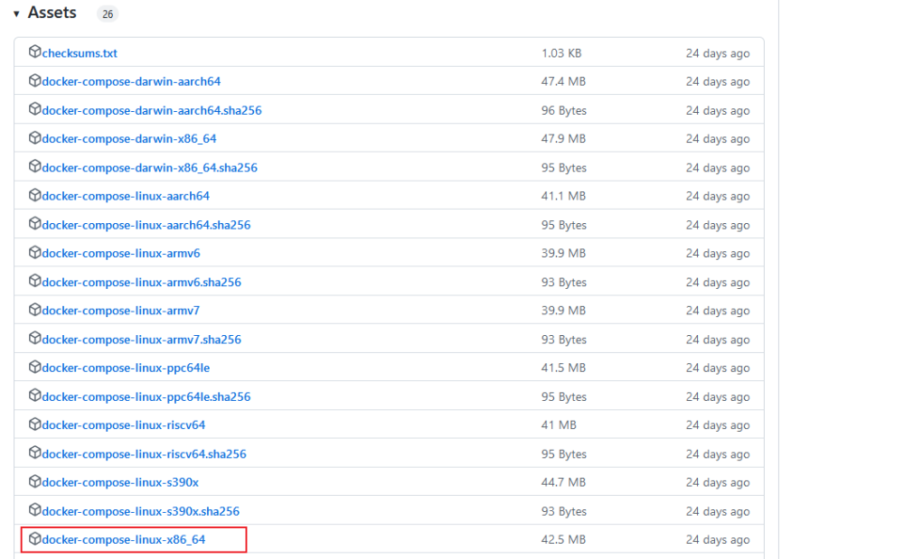

### 2 下载好离线包，把离线包放在指定目录下就不需要配置环境变量

//放到自定目录并更名  
mv docker-compose-linux-x86_64 /usr/local/bin/docker-compose  
  
//授权  
sudo chmod +x /usr/local/bin/docker-compose  
  
//查看安装是否成功  
docker-compose -v

<https://www.cnblogs.com/braveym/p/15633596.html>